
GenEmail: Optimum Email Triage for Genesys Queues
Genesys Emails Management for queue triage, spam review, and operational control
GEM gives Genesys Cloud email teams a focused triage layer for operational email queues. It helps supervisors and agents see waiting conversations, identify aging work, understand agent eligibility, manage review and spam queues, and move conversations to the right owner or queue.

What GEM does
- Allows active triage of emails in Genesys queues instead of relying only on routing configuration and individual agent views.
- Loads operational queues and shows current, handled, review, and spam activity.
- Displays email content, attachments, timeline, thread count, waiting time, and active ACD context.
- Supports actions such as Assign to Me, Assign to Agent, Assign to Skill, Move to ACD Queue, Transfer to Another Queue, Send to Review Queue, Move to SPAM, and Disconnect.
- Adds queue and agent stats so supervisors can see oldest waiting email, manual assignment counts, no eligible agents, handled volumes, spam counts, and agent eligibility reasons.
- Gives agents, supervisors, and administrators a role-aware workspace for daily email operations.

Why Genesys email teams need a triage layer
Genesys Cloud ACD is strong at routing emails to queues and agents. Its documentation describes routing by skills, language, priority, and agent utilization, and explains that priority is combined with time waiting to form an interaction score. Those controls are essential, but they are primarily configuration and routing mechanics.
In daily operations, supervisors often need a separate control surface: which queues have aging email, which emails need manual assignment, which queues have no eligible agents, which items should be sent to review, and which suspected spam items require operational disposition. GEM is designed to make those conditions visible and actionable.
Sources: Genesys Cloud Resource Center, ACD email overview; Manage ACD email routing; Malware and antispam protection best practices.

Native Genesys handling and the operational gap GEM fills
Area | Native Genesys behavior | GEM triage value
Prioritization | Priority can be configured and contributes to routing score with queue wait time. | Surfaces oldest email age, emails waiting over thresholds, and manual assignment needs so supervisors can intervene.
Spam management | Suspected spam can be routed to a flow or disconnected based on email address configuration. | Provides a spam queue/table workflow for review, counting, triage, and operational follow-up.
Queue visibility | Queues hold routed interactions and agents join queues to receive work. | Shows queue-level triage stats: waiting volume, oldest age, no eligible agents, handled totals, review count, and spam count.
Agent readiness | Agents must be on queue and available for routed work. | Shows current status, routing state, active queue status, eligibility, and reason text when an agent cannot receive ACD assignment.

Who it helps
Role | Primary need | GEM support
Agents | Find and handle the right email conversation. | Queue context, email body, attachments, timeline, and ownership actions.
Supervisors | Keep waiting work visible and balanced. | Queue stats, reassignment, transfer, review, spam table management, and workflow status visibility.
Administrators | Control tenant setup and role boundaries. | Role-aware operations, queue access support, and configuration visibility for Genesys Cloud email teams.

Application workspace
The main GEM workspace keeps the queue list, email grid, selected conversation, and action controls visible together.
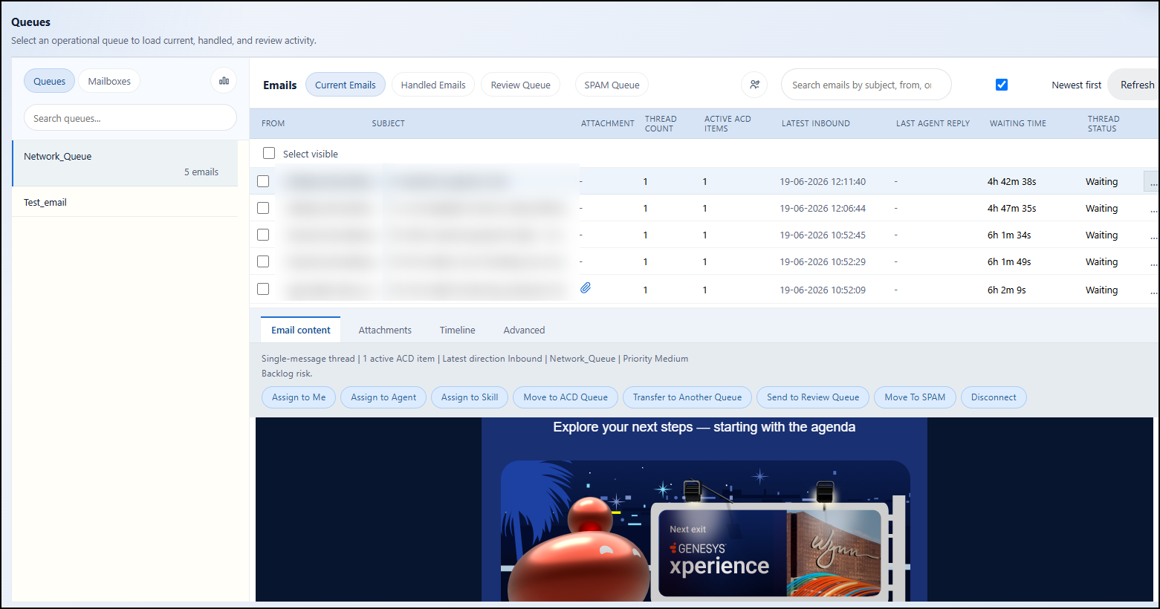

Queue dashboard
The Queue Dashboard is the supervisor triage surface. It shows emails in queue, oldest email age, emails waiting over service thresholds, manual assignment count, no eligible agents, handled emails for 7 and 30 days, emails in review, and emails in the spam queue.
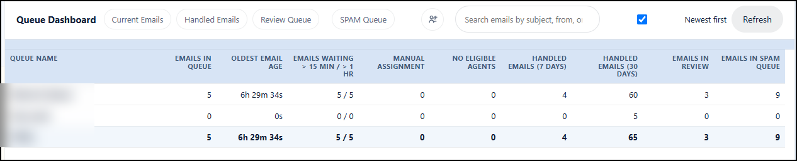

Queue agents and eligibility
The Queue Agents view makes agent readiness visible. Supervisors can see current status, routing state, email and voice counts for the day, last handled time, whether the queue is active for that agent, and why the agent is or is not eligible for assignment.
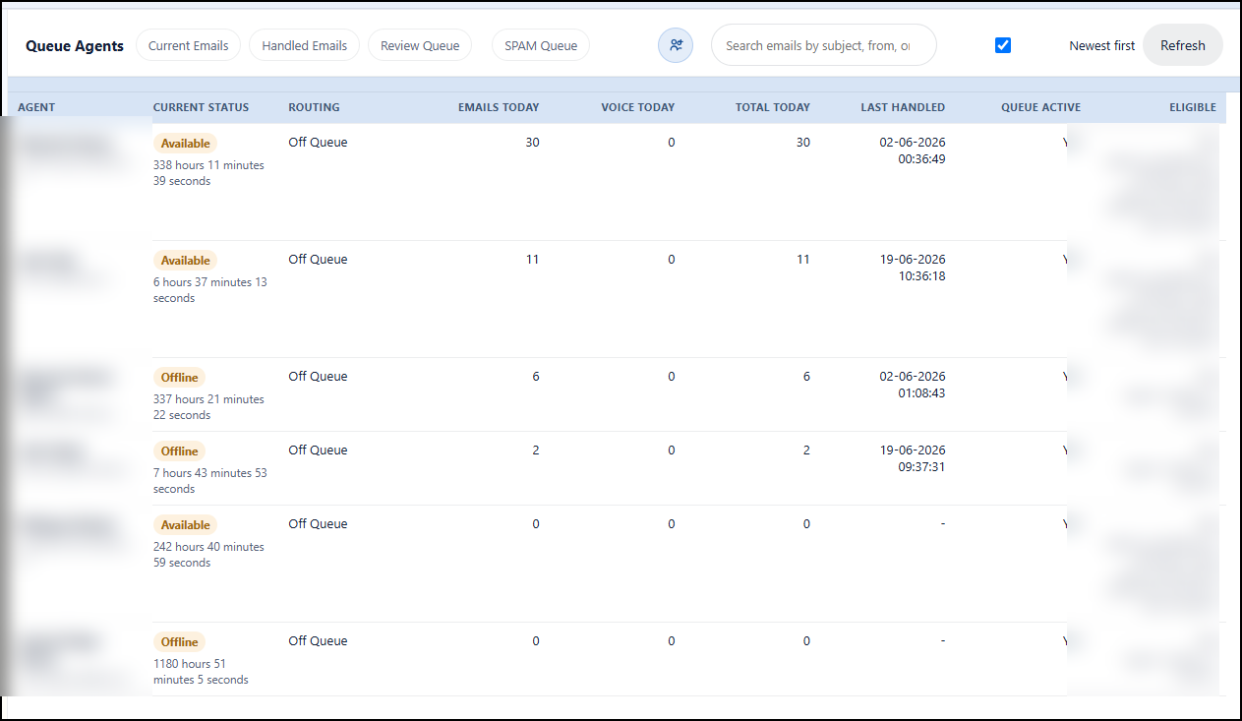

Spam table management
- Separate suspected spam from normal customer email triage.
- Review spam queue volume by queue instead of treating spam as an invisible routing setting.
- Move legitimate items back into operational handling when needed.
- Support supervisor review before disconnecting or disposing of questionable messages.

Flexible licensing: named or concurrent
GenEmail can support two licensing modes so each tenant can match licensing to the way its email operation actually works. Named licensing is best for predictable teams with specific assigned users. Concurrent licensing is best for rotating or shared teams where many approved users need access, but only a smaller number are active at the same time.
Mode | Best fit | How access is controlled
Named | Dedicated agents, supervisors, and administrators who need consistent access. | Access is tied to assigned active tenant users.
Concurrent | Shift-based teams, pooled operations, seasonal demand, and larger approved user populations. | Access is limited by active sessions, allowing approved users to share a licensed session pool.

Next step
To request a walkthrough or implementation details, contact the GenEmails team at info@genemails.com and include your company, role, phone number, Genesys Cloud region, queue volume, and the email triage problem you want to solve.

